# Hiring Process Analytics

## Akash Singh

Hiring process is the fundamental and the most important function of a company. Here, the MNCs get to know about the major underlying trends about the hiring process. Trends such as- number of rejections, number of interviews, types of jobs, vacancies etc. are important for a company to analyse before hiring freshers or any other individual. Thus, making an opportunity for a Data Analyst job here too!  
  
Being a Data Analyst, your job is to go through these trends and draw insights out of it for hiring department to work upon.  
  
You are working for a MNC such as Google as a lead Data Analyst and the company has provided with the data records of their previous hirings and have asked you to answer certain questions making sense out of that data.

**You are required to provide a detailed report for the below data record mentioning the answers of the questions that follows:**  
  
You are given a dataset of a company where the details about people who registered for a particular post in a department of this company. You are required to use your knowledge in statistics and use different formulas in excel and draw necessary conclusions about the company.  
  
Use the below **Steps for EDA**

1. Understanding data columns and data
2. Checking for missing data
3. Clubbing columns with multiple categories
4. Checking for outliers
5. Removing outliers
6. Drawing Data Summary

After downloading the dataset, use Excel or Google Sheets to answer the below questions:

1. **Hiring:** Process of intaking of people into an organization for different kinds of positions.  
   **Your task:** How many males and females are Hired ?
2. **Average Salary:** Adding all the salaries for a select group of employees and then dividing the sum by the number of employees in the group.  
   **Your task:** What is the average salary offered in this company ?
3. **Class Intervals:** The class interval is the difference between the upper class limit and the lower class limit.  
   **Your task:**Draw the class intervals for salary in the company ?
4. **Charts and Plots:**This is one of the most important part of analysis to visualize the data.  
   **Your task:**Draw Pie Chart / Bar Graph ( or any other graph ) to show proportion of people working different department ?
5. **Charts:**Use different charts and graphs to perform the task representing the data.  
   **Your task:**Represent different post tiers using chart/graph?

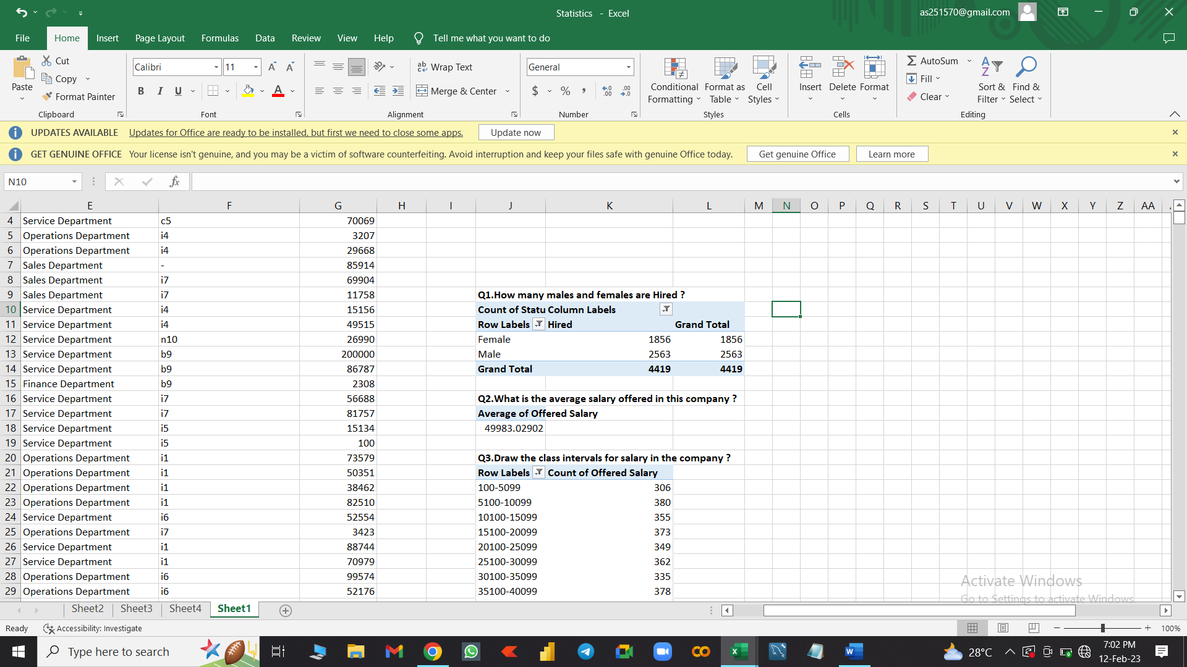

***Total 1856 female & 2563 males got hired .***

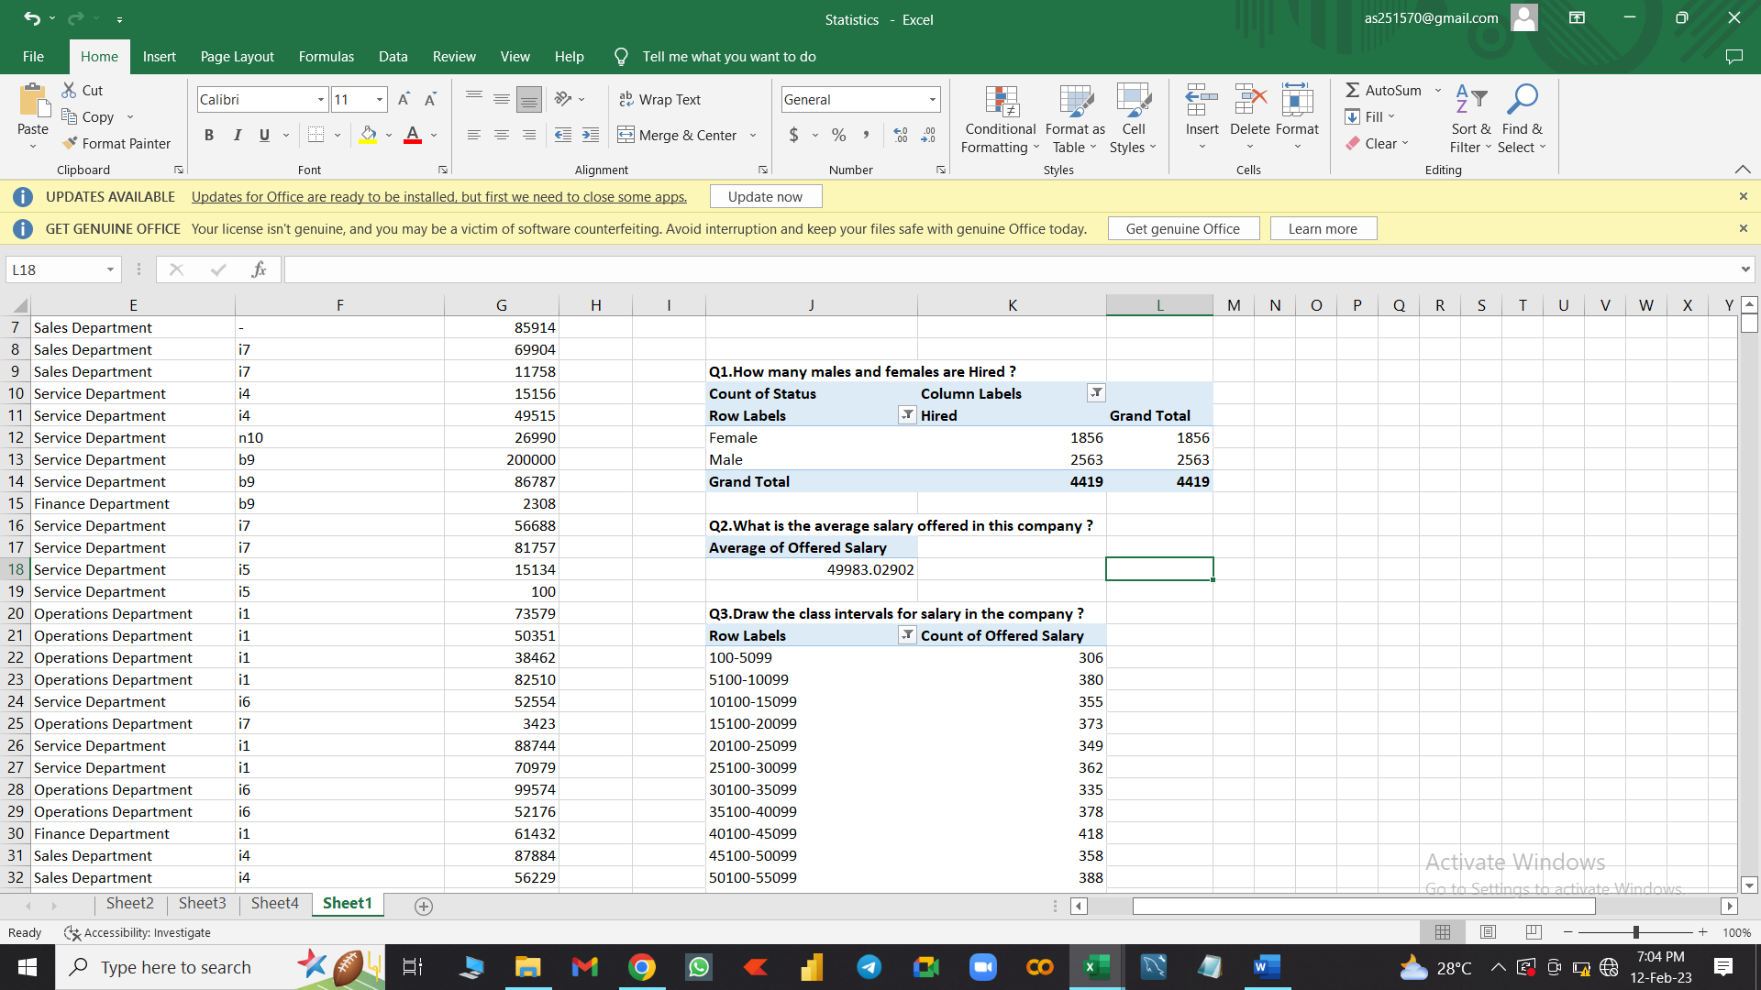

***Average offered salary by the company – 49983.029***

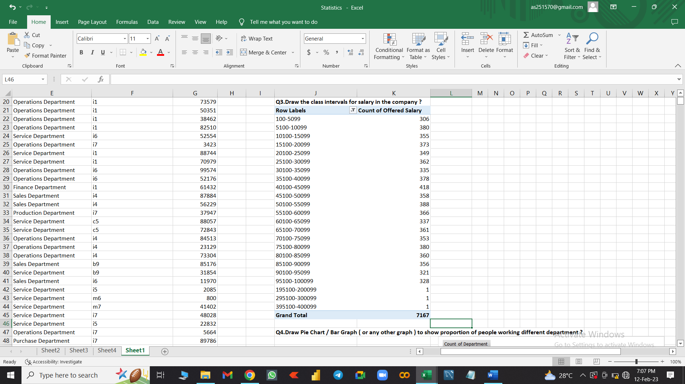

***Starting =100 , Ending =400000 , by= 5000***



